2 Methods
2.0 Overview of Modeling Framework
To estimate the potential impact of biosolids application on PFAS transport through the soil profile and into groundwater, we developed a conceptual modeling framework that integrates source-term estimation, vadose zone leaching simulation, and saturated zone transport analysis. This multi-step approach allows for the prediction of PFAS concentrations in biosolids-amended surface soils and the subsequent concentrations at down-gradient groundwater receptors.
The modeling framework (Figure S1) consists of three sequential components:
- estimation of PFAS concentrations in PFAS Source Zone following biosolids application,
- simulation of PFAS leaching from the source zone to the saturated zone using a two-site kinetic sorption model, and
- attenuation of PFAS during groundwater transport using a simplified analytical solution for dilution and dispersion.
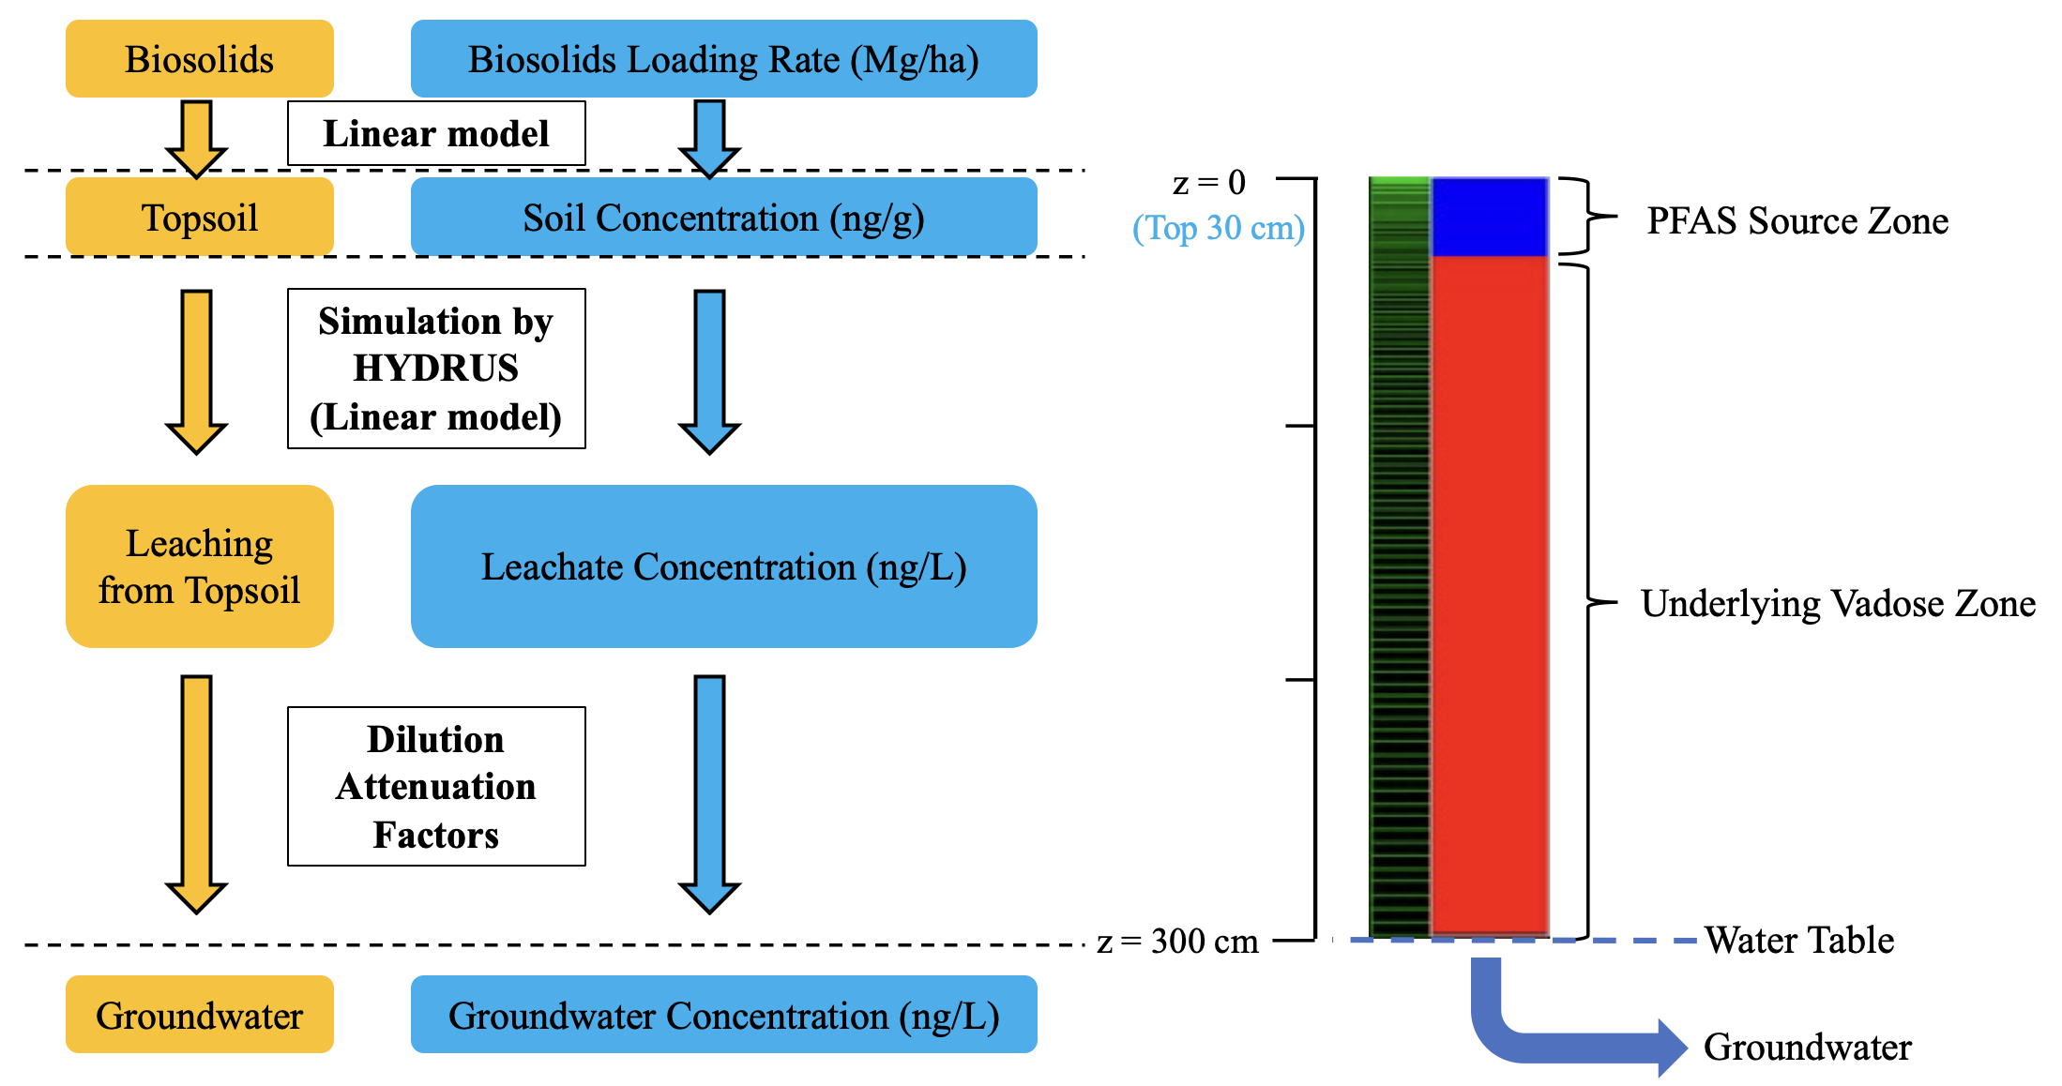
Figure S1. Modeling Framework for Estimating PFAS Concentrations from Biosolids to Groundwater
This approach provides a streamlined method to estimate environmental concentrations of PFAS at various points along the source-to-receptor pathway. It supports site-specific exposure assessment related to land application of biosolids.
2.1 biosolids-amended soil concentration estimation
Two representative agricultural field sites were selected by Silva et al. (2022) to simulate biosolids-amended soil conditions: a fine sandy soil (Site K, Chelsea fine sand: mixed, mesic, Alfic Udipsamments) and a heavy clay soil (Site W, Ashkum silty clay loam: fine, mixed, mesic, Typic Haplaquolls). These sites were part of a three-year field-scale experiment initiated in Fall 2004 by the Metropolitan Water Reclamation District of Greater Chicago to evaluate the effects of Class B biosolids on soil fertility and corn yield. Detailed site descriptions and experimental design are available in Higgins et al. (2011).
To parameterize PFAS concentrations in biosolids-amended surface soils, we adopted the linear regression model established by Sepulvado et al. (2011), which relates the PFAS source strength to the cumulative biosolids loading rate (BLR). Specifically, the biosolids-amended soil concentration of PFAS ($S_{BS,PFAS}$, ng/$g_{soil}$) is modeled as a linear function of BLR (Mg/ha), expressed as:
$$\begin{aligned}S_{BS,PFAS}=α×BLR\#\left(Eq.1\right)\end{aligned}$$
where α is the compound-specific regression slope derived from field observations, representing the increase in soil PFAS concentration per unit increase in biosolids loading. Representative values of α for PFAS compounds of interest in this study were obtained from Sepulvado et al. (2011) and are summarized in Table S1.
To account for background contamination, the total PFAS concentration in amended soils was calculated as the sum of the modeled PFAS contribution from biosolids ($S_{BS,PFAS}$) and the baseline PFAS concentration in unamended soils (S₀):
$$\begin{aligned}S_{Total}=S_{0}+S_{BS,PFAS}\#\left(Eq.2\right)\end{aligned}$$
Table S1. Regressions for PFAS soil concentration with loading rate (from Sepulvado et al., 2011).
PFAS | Regression Slope | R²
PFHxA | 0.003 | 0.84
PFHpA | 0.003 | 0.92
PFOA | 0.015 | 0.94
PFNA | 0.003 | 0.94
PFDA | 0.009 | 0.97
PFHxS | 0.004 | 0.94
PFOS | 0.198 | 0.91
Note: regression intercept = 0; PFAS soil concentration (ng/g) = slope $×$ biosolids loading rate (Mg/ha)
2.2 leachate concentration estimation
To estimate PFAS leachate concentrations resulting from biosolids application, we referred to the modeling framework established by Silva et al. (2022), which employed a two-site kinetic sorption model embedded within the HYDRUS simulation platform. This model was used to simulate PFAS transport in the vadose zone following a single biosolids application event.
To capture the long-term leaching behavior of different PFAS compounds, simulations were extended over a 150-year period post-application. Due to compound-specific differences in sorption-desorption kinetics, the peak leachate concentrations ($C_{w,max}$) varied temporally among different PFAS analytes. Importantly, the model incorporated adsorption of PFAS at air-water interfaces (AWI) within the unsaturated zone, which represents an additional mechanism of retention and retards vertical transport.
A linear regression relationship (Eq. 3) was developed between the maximum leachate concentration reaching the saturated zone ($C_{w,max}$, ng/L) and the total PFAS concentration in biosolids ($S_{Total}$, ng/g):
$$\begin{aligned}C_{w,max}=β×S_{Total}\#\left(Eq.3\right)\end{aligned}$$
Compound-specific slope coefficients (β) derived from the HYDRUS simulation outputs are summarized in Table S2. These coefficients reflect the proportionality between PFAS content in biosolids and the peak leachate concentrations in the saturated zone for a single-application scenario.
Table S2. Regression slopes from $S_{Total}$-$C_{w,max}$ linear regressions (from Silva et al., 2011).
PFAS | Site K | Site W
PFHxA | 174.71 | 131.31
PFHpA | 94 | 79.468
PFOA | 128.45 | 101.39
PFNA | 54.3 | 59.08
PFDA | 14.1 | -
PFHxS | 56.8 | 23.2
PFOS | 11.34 | 8.09
Note: R² for each linear regression had unit value. For Site W, PFDA peak did not arrive within 150 years after applying biosolids.
2.3 Groundwater Concentration Estimation
To estimate PFAS concentrations at a down-gradient receptor (e.g., a groundwater well or adjacent surface water body), attenuation processes during transport through the saturated zone were considered. These processes include dilution and dispersion, which can significantly reduce contaminant concentrations with increasing distance from the source.
We applied a simplified analytical solution for solute transport in saturated porous media, adapted from Silva et al. (2022), to quantify the attenuation of PFAS leachate between the source zone and receptor location. The solution expresses the dilution attenuation factor (DAF) as a function of source dimensions and hydrogeological parameters (Eq. 4):
$$\begin{aligned}\frac{C}{C_{o}}=\frac{1}{DAF}=\left\{erf\left[\frac{Y}{4\sqrt{α_{y}x}}\right]erf\left[\frac{δ_{gw}}{2\sqrt{α_{z}x}}\right]\right\}\#\left(Eq.4\right)\end{aligned}$$
where:
$C$ = Dissolved-phase concentration (ML⁻³)
$C_{o}$ = Dissolved-phase concentration at the source (ML⁻³)
$x$ = Spatial coordinates (L)
$α_{y}$ = Lateral dispersivity (L)
$α_{z}$ = Vertical dispersivity (L)
$Y$ = Width of the soil source area perpendicular to the groundwater flow direction (L)
$δ_{gw}$ = Groundwater mixing zone thickness (L)
$DAF$ = Dilution attenuation factor (-) = $C_{o}/C$
For this analysis, site-specific parameter values were adopted based on assumptions from prior literature and common practice in vadose zone modeling. Specifically, the width of the source area (Y) was assumed to be 5 meters, representing a typical biosolids application width perpendicular to groundwater flow. The groundwater mixing zone thickness ($δ_{gw}$) was set at 2 meters. Lateral and vertical dispersivities were assumed to be 0.5 meters and 0.1 meters, respectively.
This approach enables estimation of PFAS concentrations at the receptor location by applying the DAF to the modeled leachate concentration ($C_{w,max}$) reaching the saturated zone. It thus provides a simplified yet robust method for linking source-term modeling with potential exposure concentrations at downgradient points of concern.
Reference:
Higgins, C. P., Paesani, Z. J., Abbott Chalew, T. E., Halden, R. U., & Hundal, L. S. (2011). Persistence of triclocarban and triclosan in soils after land application of biosolids and bioaccumulation in <i>Eisenia foetida</i>. Environmental Toxicology and Chemistry, 30(3), 556-563. https://doi.org/10.1002/etc.416
Sepulvado, J. G., Blaine, A. C., Hundal, L. S., & Higgins, C. P. (2011). Occurrence and Fate of Perfluorochemicals in Soil Following the Land Application of Municipal Biosolids. Environmental Science &amp; Technology, 45(19), 8106-8112. https://doi.org/10.1021/es103903d
Silva, J. A. K., Guelfo, J. L., Šimůnek, J., & McCray, J. E. (2022). Simulated leaching of PFAS from land-applied municipal biosolids at agricultural sites. Journal of Contaminant Hydrology, 251, 104089. https://doi.org/https://doi.org/10.1016/j.jconhyd.2022.104089

